https://www.youtube.com/watch?v=bBFnIuqFutc

1. **File / Preferences**

https://dl.espressif.com/dl/package_esp32_index.json, <http://arduino.esp8266.com/stable/package_esp8266com_index.json>

1. **Tools / Board / Board Manager**



Busca: Heltec ESP32

1. **Sketch / Include Library. Manage Libraries**

Busca: Heltec ESP32

1. **Select Board**

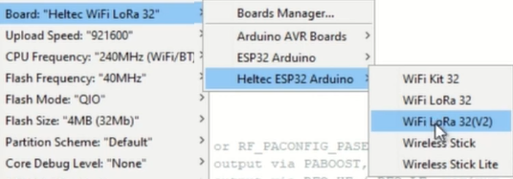

1. **Examples**

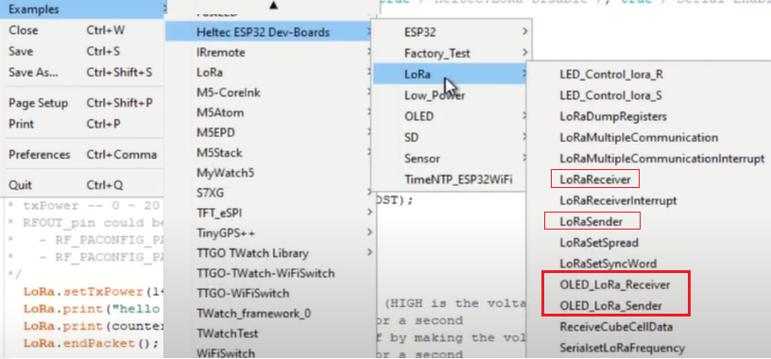

|  |  |
| --- | --- |
| Sender | Receiver |
|  |  |
|  |  |